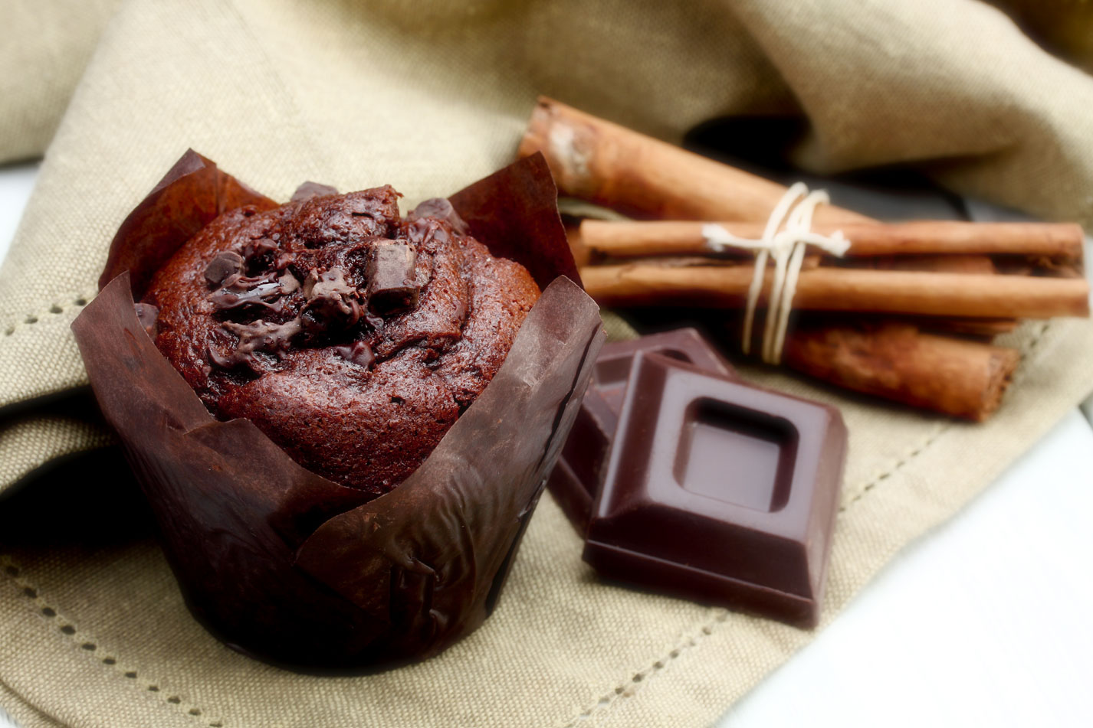

TIME
PREP 25M COOK 30M

INGREDIENTS
2 1/4 cups self-raising flour, sifted
1/2 cup cocoa powder, sifted
1 cup caster sugar
3/4 cup dark chocolate chips
1/2 cup vegetable oil
2/3 cup milk
1 teaspoon vanilla extract
2 eggs

Chocolate Muffin

Step 1
Preheat oven to 180°C/160°C fan-forced. Line a 12-hole, 1/3 cup-capacity muffin pan with paper cases.

Step 2
Combine flour, cocoa, sugar and chocolate chips in a large bowl. Make a well in centre. Whisk vegetable oil, milk, vanilla and eggs in a large jug. Add oil mixture to well (see Cooking class, below). Using a wooden spoon, stir until just combined (don't over-mix). Spoon mixture into paper cases.

Step 3
Bake for 25 minutes or until firm to touch and a skewer inserted into the centre comes out clean. Stand in pan for 5 minutes. Transfer to a wire rack to cool. Serve.

